CHAIRS

Bryce Hairston Kennard

Vicki Luna

HONOREES

Paula Mendoza

Bank of America Summer Youth

Employment Program

HOST COMMITTEE

Nadia and Terry Bruner

Oriana Durbin

Jason Fuller

Tracy and Ken Janda

Harriet Latimer

Reinnette and Stan Marek

Cathryn Martinez

Ann and Mark McCullough

Sara Montelongo-Oyervidez

Arcy Munoz

William L. Peel, Jr.

Tricia and Steve Rosencranz

Gracie Saenz

Vanessa Solá

Crystal Taylor

Barbara Van Postman

BOARD

Paula Mendoza, Chair

Bryan Neely, Vice Chair

Marc McCullough, Treasurer

Gwendolyn Tillotson Bell, Secretary

Lori Arnold

Christen Bagley

Rasheeda Carr

Ricky Cortez

Thuy Geraci

Chris Harlow

Vicki Luna

Sonia Miyazono

Hugo Mojica

Daniel Saenz

Diane Schenke

Dr. Frances Villagran-Glover

Talor Thompson, Rice Fellow

CDC CHAIR

Steve Rosencranz

CHIEF EXECUTIVE OFFICER

Sheroo Mukhtiar



February 2, 2024

Dear Friend of SERJobs,

We invite you to join us for SERJobs’ **Champions of Hope** Luncheon, on **Friday, June 7, 2024**, at T**he Ballroom at Bayou Place**. We have the pleasure of honoring **Paula Mendoza** and the **Bank of America Summer Youth Employment Program** for their support of SERJobs and its members.

*Native Houstonian whose parents were born in Mexico;* ***Paula Mendoza*** *is an entrepreneur from the Northside. Paula has served as the Chair for SERJobs since September 2022. She owns and manages three businesses; Possible Missions, a procurement firm, Pos Mis Inc, a project management firm, and Possible Properties, LLC. Under her leadership, she helped SERJobs open its new Workforce Resource and Training Center in early 2023.*

*For the past 11 years in the Greater Houston area, the* ***Bank of America Summer Youth Employment Program*** *has provided eight-week paid internships to nearly 1,000 youth, in partnership with SERJobs. The interns are strategically placed with area nonprofits and Bank of America financial centers during which they grow and thrive as professionals and community leaders while gaining job experience.*

We believe that SERJobs is worthy of our enthusiastic support. Almost no other organization can turn every donated dollar into seven more. These much-needed funds help support SERJobs’ mission *to transform the lives of individuals through education, skill-based training, employment, and long-term financial stability.* SERJobs is WHERE OPPORTUNITY WORKS!

Please respond by **April 15, 2024** to be included in the invitation. You may return the enclosed sponsorship form by emailing Beth Wilson [at ewilson@serjobs.org](mailto:ewilson@serjobs.org) or mailing to 1710 Telephone Rd., Houston, TX 77023.

Thank YOU for your generous consideration in supporting a cause so dear to our hearts. We look forward to hearing from you!

With warm wishes,

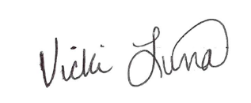 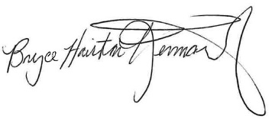

Vicki Luna, HEB Bryce Kennard, Comcast

Co-Chair Co-Chair